**Always up-to-date with the CADENAS Industry-Forum**

International specialists convention once again offers the latest information and networking for industrial companies and component manufacturers

**Augsburg, Germany, 22nd March 2016.** At the 17th Industry-Forum on 8th and 9th March, more than 200 international visitors from the mechanical, plant and electrical engineering sector were informed about innovations and trends regarding sustainable cost reduction with strategic parts management, expanding marketing opportunities with electronic CAD product catalogs and building information modeling (BIM) ath the WWK arena in Augsburg.

**Listening as prerequisite for successful innovations**

The Industry-Forum was kicked-off by a keynote from Jürgen Heimbach, CEO at CADENAS, who provided an outlook to the technical innovations companies can expect in the near future.

Every year the keynote provides the opportunity for further conversations, which are especially important to Jürgen Heimbach. By communicating and listening, the software manufacturer can learn about the customers’ needs and realize them completely. “This is exactly the point where we are significantly different from our market competitors – we listen. The Industry-Forum therefore offers perfect framework for us and our customers: Two days when users and developers can exchange. The customers, however, know that their requirements and ideas are always positioned at the right place“, the CEO of CADENAS explains.

**Long-term growth needs flexibility**

In his presentation, Jürgen Heimbach explained why CADENAS prefers to react flexibly: “Imagine steering on a certain course and suddenly a new important technology rises on the horizon. How would you react?“ As an example, he cited Facebook: “Who would have thought in 2008 that Facebook would become so extremely important to all marketing strategists and in the media world?“

Another example he cited was the growing importance of smartphones for private and professional use and thus confirms research observations. The keyword here is disruptive technologies. Within 5 years, pioneering technologies have changed the general behavior and decisions of users.

Interested parties were able to learn more about the up-to-dateness of smartphones for professional and private use at the Marketing Club Augsburg presentation about IT consumerization, which took place at the Faculty of Economics, University of Augsburg. Also digital transformation will be one of the topics facing companies in the coming years.

**Keep the ball**

CADENAS pursues other methods as kind of a long-term strategy: Customer ideas and requests are combined with CADENAS’ know-how to identify new ideas and and design new innovations at an early stage. In doing so, the focus is on state-of-the art software.

The software manufacturer from Augsburg is also inspired by other innovative ideas to transfer them to CADENAS-owned applications and features:

For instance, the existing help function of the 3D CAD model download portal PARTcommunity is to be completely renewed and taken to the next level. In the long-term, the renewal will facilitate accessing the download portal for first users.

**Practical experience reports of renowned companies**

With around 20 best practice presentations of renowned companies on topics such as the successful support of PARTsolutions at GE Oil & Gas projects, the electronic product catalog as the CAD market place of a company or preparing a switch from Ideas to NX, as well as interactive workshops, the international specialists convention attracted participants from Germany, Austria, Great Britain, Italy, Asia, France, Sweden, Norway, Switzerland and Turkey. The Forum was complemented by an integrated trade exhibition of numerous renowned companies, such as the keytech Süd GmbH, the CINTEG AG, the DSC AG and many more.

This year’s motto of the annual home game, the Industry-Forum’s evening event, was “Champions made in Augsburg who know everybody #jedesau“, where visitors demonstrated in various games around leather ball that they also belong to the premier league. The visitors especially enjoyed taking part in the stadium tour to find out more about the homestead of FCA.

For further information about the CADENAS Industry Forum, please visit: <http://www.industry-forum.biz>

Impressions of the evening event, as well as pictures and presentations for download are available under:

<http://www.industry-forum.biz/rueckblick/2016>

**Press Images:**

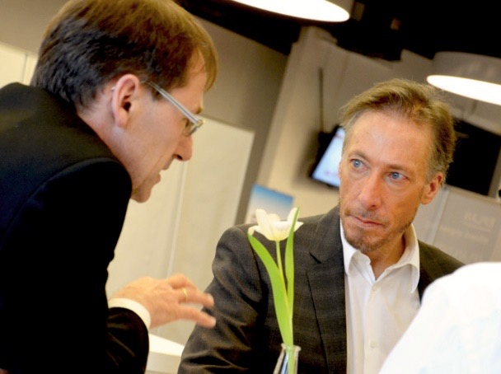

**Caption 1:** By communicating and listening, the software manufacturer CADENAS can learn about the customers’ needs and realize them completely.

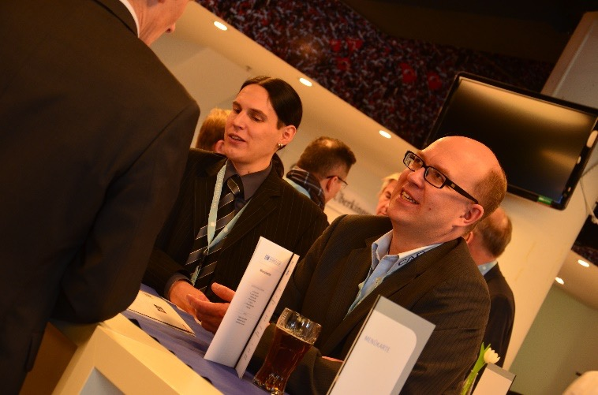

**Caption 2:** The outlook on upcoming technical innovations was lively discussed at the 17th Industry-Forum.

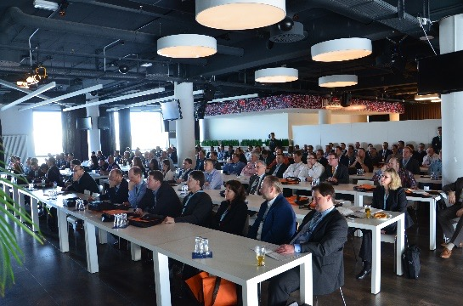

**Caption 3:** With around 20 best practice presentations of renowned companies as well as interactive workshops, the international specialists convention attracted 200 participants from all over the world.

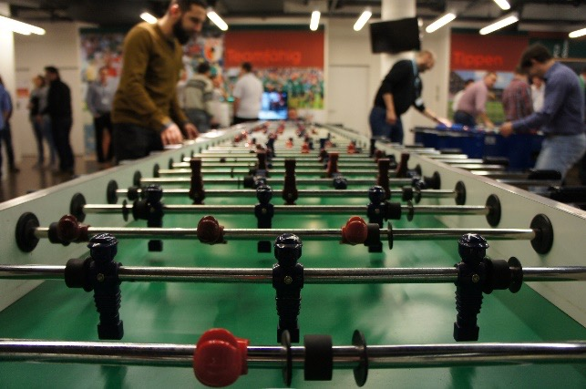

**Caption 4:** In various games around leather ball the customers could show they also belong to the premier league.

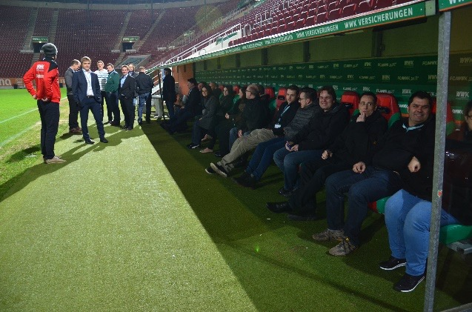

**Caption 5:** The visitors especially enjoyed taking part in the stadium tour to find out more about the homestead of FCA.

This press release and accompanying images are available for download from our website: [www.cadenas.de/press/press-releases](http://www.cadenas.de/press/press-releases)

**About CADENAS**

CADENAS is a leading software developer in the areas of Strategic Parts Management and parts reduction (PARTsolutions), as well as Electronic Product Catalogs (eCATALOGsolutions). With its customized software solutions, the company acts as a link between the component manufacturers with their products and the purchasers.

With its 300 employees at 17 international subsidiaries, the name CADENAS (Hispanic: process chains) has been standing for success, creativity, support and process optimization since 1992.

For further information, please visit: www.cadenas.de/en